**DAILY ONLINE ACTIVITIES SUMMARY**

|  |  |  |  |  |  |  |  |  |
| --- | --- | --- | --- | --- | --- | --- | --- | --- |
| **Date:** | **2-7-2020** | | | | | **Name:** | **Prajna** | |
| **Sem & Sec** | **8th sem ‘B’** | | | | | **USN:** | **4AL16CS067** | |
| **Online Test Summary** | | | | | | | | |
| **Subject** | | **-** | | | | | | |
| **Max. Marks** | | **-** | | **Score** | | | **-** | |
| **Certification Course Summary** | | | | | | | | |
| **Course** | **Introduction to CSS** | | | | | | | |
| **Certificate Provider** | | | **Great learning** | | **Duration** | | | **5hrs** |
| **Coding Challenges** | | | | | | | | |
| **Problem Statement:**1**.** Write a c program to delete element from desired position from array. | | | | | | | | |
| **Status: Completed** | | | | | | | | |
| **Uploaded the report in GitHub**  **GitHub link:** | | | | | **Yes**  **https://github.com/alvas-education-foundation/prajna_k** | | | |
| **If yes Repository name** | | | | | **prajna_k** | | | |
| **Uploaded the report in slack** | | | | | **yes** | | | |

Online Test Details: (Attach the snapshot and briefly write the report for the same)

Certification Course Details: (Attach the snapshot and briefly write the report for the same)

Coding Challenges Details: (Attach the snapshot and briefly write the report for the same)

2) certification course

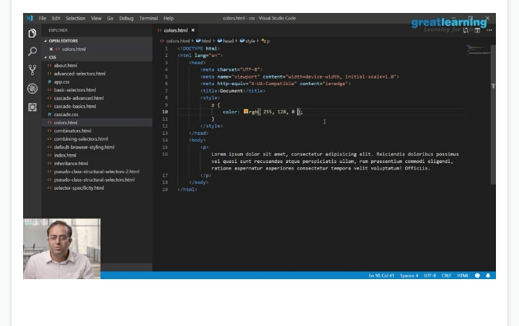

3) coding challenges

#include <stdio.h>

void main(){

int arr1[50],i,pos,n;

printf("\n\nDelete an element at desired position from an array :\n");

printf("---------------------------------------------------------\n");

printf("Input the size of array : ");

scanf("%d", &n);

/* Stored values into the array*/

printf("Input %d elements in the array in ascending order:\n",n);

for(i=0;i<n;i++)

{

printf("element - %d : ",i);

scanf("%d",&arr1[i]);

}

printf("\nInput the position where to delete: ");

scanf("%d",&pos);

/*---- locate the position of i in the array -------*/

i=0;

while(i!=pos-1)

i++;

/*---- the position of i in the array will be replaced by the

value of its right */

while(i<n){

arr1[i]=arr1[i+1];

i++;

}

n--;

printf("\nThe new list is : ");

for(i=0;i<n;i++)

{

printf(" %d",arr1[i]);

}

printf("\n\n");

}

|  |
| --- |
|  |
|  |  |
|  |  |
|  |  |
|  |  |
|  |  |